Nama : Pradana Argo Pangestu

Nim : 2311104079

JURNAL MODUL 6

1. 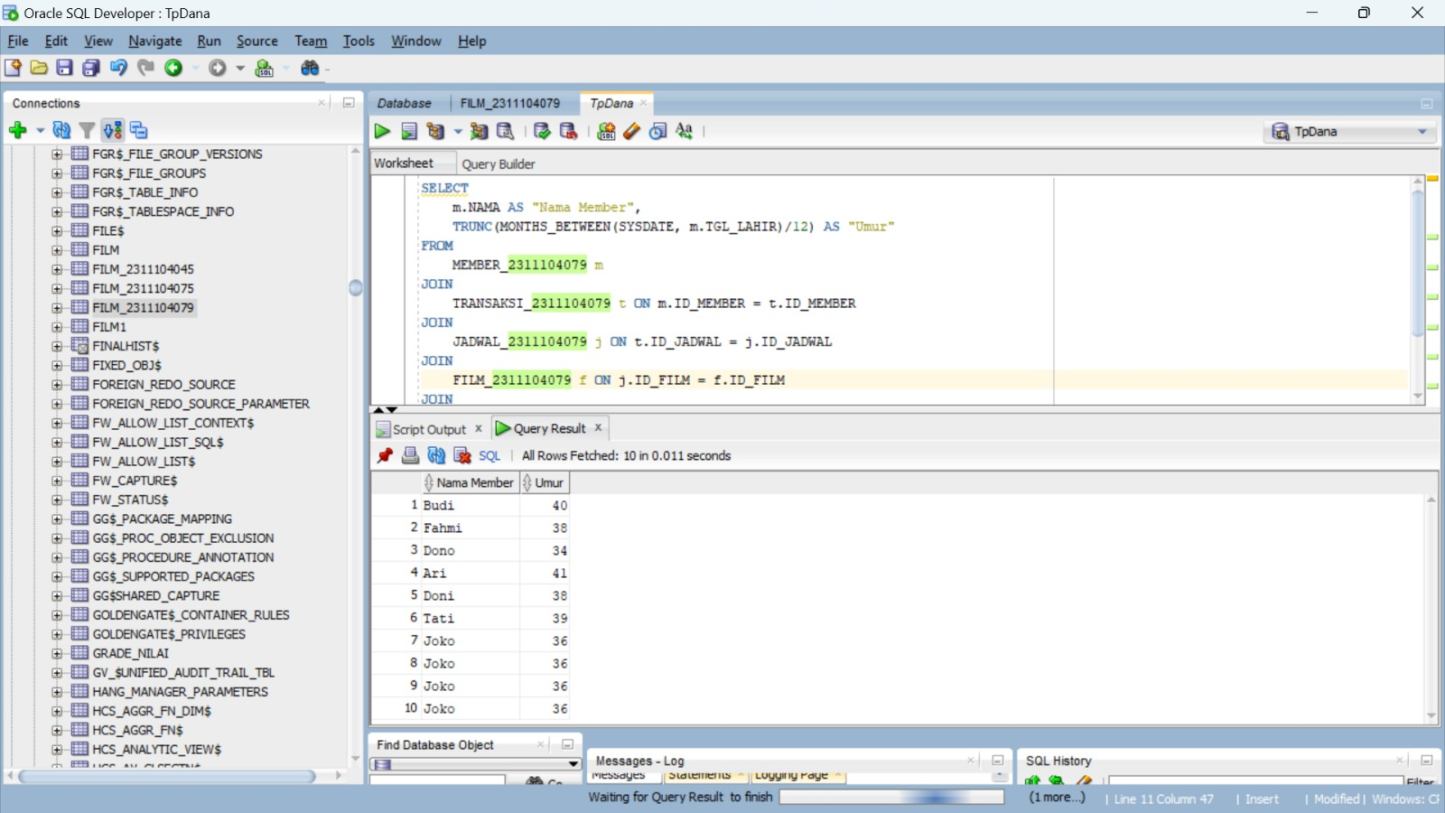

SELECT

m.NAMA AS "Nama Member",

TRUNC(MONTHS_BETWEEN(SYSDATE, m.TGL_LAHIR)/12) AS "Umur"

FROM

MEMBER_2311104079 m

JOIN

TRANSAKSI_2311104079 t ON m.ID_MEMBER = t.ID_MEMBER

JOIN

JADWAL_2311104079 j ON t.ID_JADWAL = j.ID_JADWAL

JOIN

FILM_2311104079 f ON j.ID_FILM = f.ID_FILM

JOIN

THEATER_2311104079 th ON j.ID_THEATER = th.ID_THEATER

WHERE

th.HARGA > (SELECT HARGA FROM THEATER_2311104079 WHERE ID_THEATER = 'Teater 1')

AND f.JUDUL = 'Habibie Ainun 3';

1. 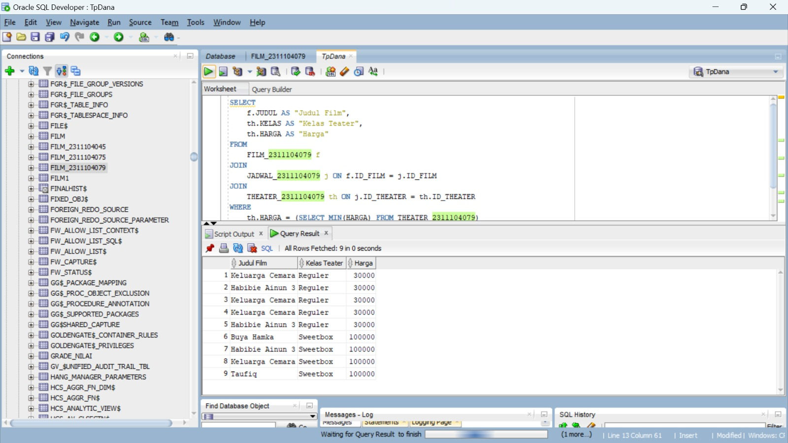

SELECT

f.JUDUL AS "Judul Film",

th.KELAS AS "Kelas Teater",

th.HARGA AS "Harga"

FROM

FILM_2311104079 f

JOIN

JADWAL_2311104079 j ON f.ID_FILM = j.ID_FILM

JOIN

THEATER_2311104079 th ON j.ID_THEATER = th.ID_THEATER

WHERE

th.HARGA = (SELECT MIN(HARGA) FROM THEATER_2311104079)

OR th.HARGA = (SELECT MAX(HARGA) FROM THEATER_2311104079)

ORDER BY

th.HARGA;

1. 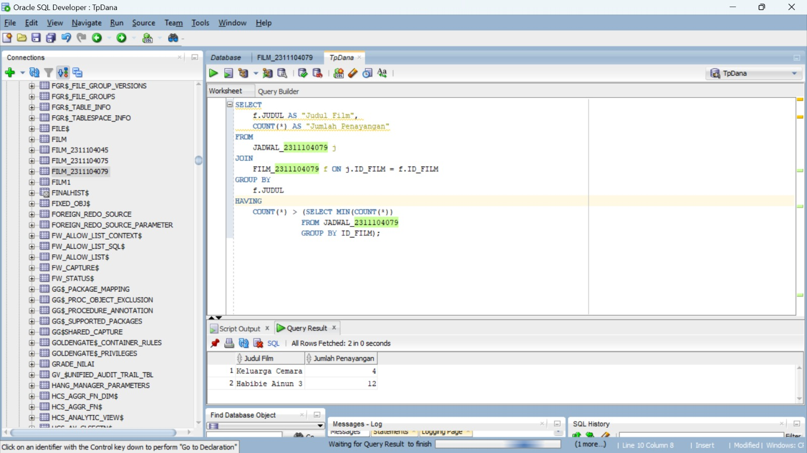

SELECT

f.JUDUL AS "Judul Film",

COUNT(*) AS "Jumlah Penayangan"

FROM

JADWAL_2311104079 j

JOIN

FILM_2311104079 f ON j.ID_FILM = f.ID_FILM

GROUP BY

f.JUDUL

HAVING

COUNT() > (SELECT MIN(COUNT())

FROM JADWAL_2311104079

GROUP BY ID_FILM);

1. 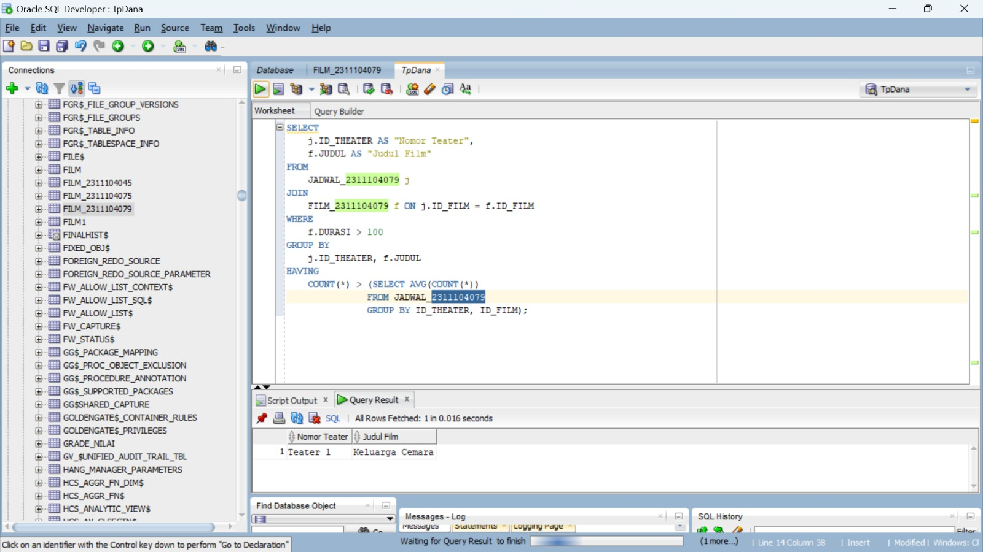

SELECT

j.ID_THEATER AS "Nomor Teater",

f.JUDUL AS "Judul Film"

FROM

JADWAL_2311104079 j

JOIN

FILM_2311104079 f ON j.ID_FILM = f.ID_FILM

WHERE

f.DURASI > 100

GROUP BY

j.ID_THEATER, f.JUDUL

HAVING

COUNT() > (SELECT AVG(COUNT())

FROM JADWAL_2311104079

GROUP BY ID_THEATER, ID_FILM);

1. 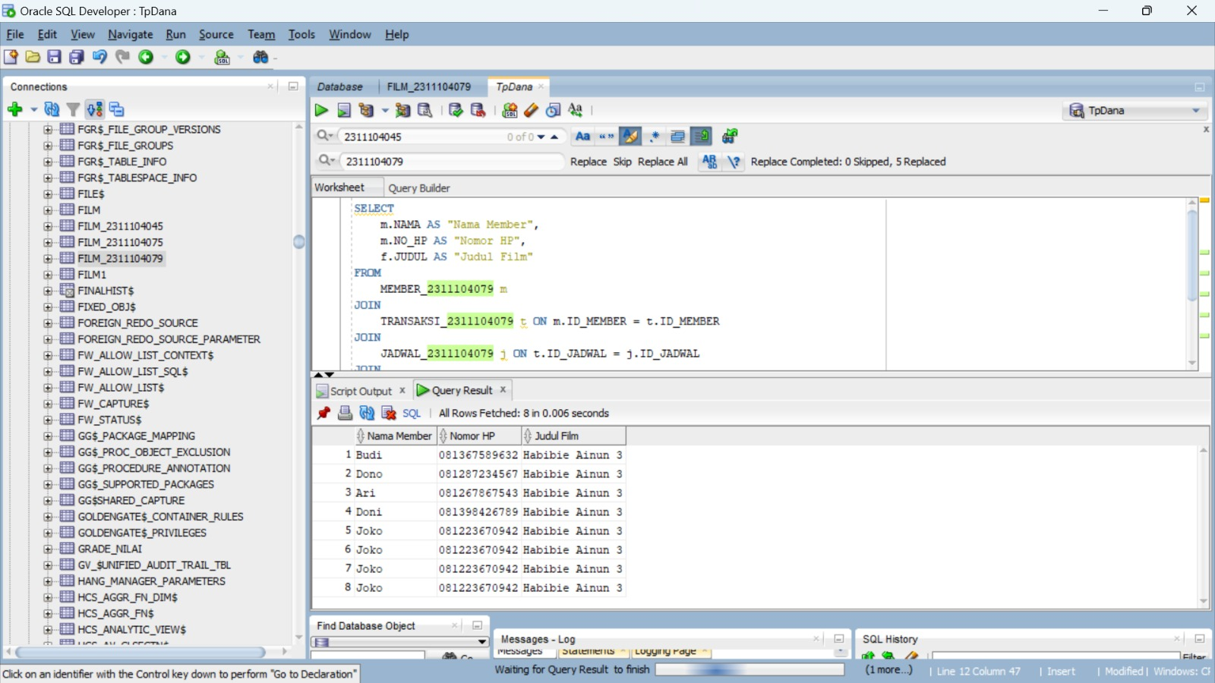

SELECT

m.NAMA AS "Nama Member",

m.NO_HP AS "Nomor HP",

f.JUDUL AS "Judul Film"

FROM

MEMBER_2311104079 m

JOIN

TRANSAKSI_2311104079 t ON m.ID_MEMBER = t.ID_MEMBER

JOIN

JADWAL_2311104079 j ON t.ID_JADWAL = j.ID_JADWAL

JOIN

FILM_2311104079 f ON j.ID_FILM = f.ID_FILM

JOIN

THEATER_2311104079 th ON j.ID_THEATER = th.ID_THEATER

WHERE

th.HARGA > 30000

AND m.NO_HP LIKE '081%';